- What exchanges were promised within the feudal system? (King to Noble, Noble to Knight, Knight to Peasant, Peasant to Knight, Knight to Noble, Noble to King)
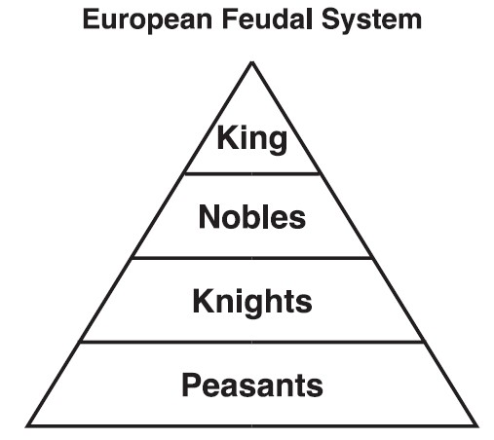
- Why did feudalism develop?
- Describe the life of a serf. Describe the difference between a serf and a freeman.
- Describe the difference between the responsibilities and lives of noble men and women.
- Describe the process a person went through to become a knight.
- What are some ways Gothic architecture symbolized the Christian faith?
- Where did education take place during the Medieval Period?
- Why was Thomas Aquinas a significant philosopher for the church? What did he do?
- Describe two reasons towns grew during the Medieval Period.
- What were the purposes of guilds?
- How was the Black Death spread? How did it enter and spread throughout Europe?
- Describe a common treatment for diseases in the Medieval Period.
- Describe the why the Plague, Magna Carta and Model Parliament led to the decline of feudalism
Key Terms:
Manor System Domain Charter Guild
Feudalism Vassal Fief Squire
Self Sufficient Serf Chivalry Apprentice
Cruciform Natural Law Surplus Black Death
Trial by Combat Trial by Ordeal Anti-Semitism Magna Carta

